Game Design Document: "The Firewall Breach"
Game Concept
Title: The Firewall Breach
Genre: Cooperative Cyber Security Escape Room
Platform: LAN-based PC Game
Target Audience: GCSE Students (Years 10-12)
Player Count: 4 Players
Executive Summary
A cooperative digital escape room where players work as IT interns to contain a cyber attack at "CyberCorp" within 30 minutes, solving interconnected IT puzzles to prevent total data loss.

Core Gameplay Overview
Objective
Work together to identify and neutralize a malicious hacker who has locked down the server room, restoring system control before the 30-minute timer expires.
Game Flow
- Phase 1: Detection - Identify the breach source
- Phase 2: Analysis - Understand the attack method
- Phase 3: Containment - Isolate infected systems
- Phase 4: Elimination - Deploy countermeasures
- Phase 5: Recovery - Restore systems and escape

Player Roles & Responsibilities
Role 1: Network Tracker
Primary Tools:
- Interactive network topology map
- IP address tracker
- Connection monitoring dashboard
Key Responsibilities:
- Trace malicious activity across the network
- Identify compromised devices
- Monitor data flow patterns
- Provide location data to team members
STEM Focus: Network fundamentals, logical reasoning, spatial awareness
Role 2: Code Breaker
Primary Tools:
- Code editor with syntax highlighting
- Debugging console
- Script repository
Key Responsibilities:
- Analyze and repair corrupted scripts
- Decrypt security codes
- Identify vulnerabilities in code
- Create patches for exploited weaknesses
STEM Focus: Programming logic, problem-solving, pattern recognition
Role 3: Security Analyst
Primary Tools:
- Security event logs
- Email and communication monitors
- User activity reports
Key Responsibilities:
- Identify phishing attempts
- Analyze security breach patterns
- Spot suspicious user behavior
- Provide attack context to the team
STEM Focus: Cybersecurity principles, analytical thinking, risk assessment
Role 4: Systems Operator
Primary Tools:
- Master control panel
- System status dashboard
- Remote administration tools
Key Responsibilities:
- Execute containment procedures
- Deploy security patches
- Manage system reboots
- Coordinate final recovery steps
STEM Focus: Systems management, procedural thinking, coordination

Puzzle Interdependence System
Example Workflow
text
Security Analyst
↓ (discovers suspicious IP in phishing email)
Network Tracker
↓ (locates infected device on network map)
Code Breaker
↓ (repairs corrupted access script from device)
Systems Operator
↓ (deploys patch and quarantines device)
Key Interdependence Mechanics
- Information Sharing: Critical clues are distributed across different roles
- Sequential Unlocking: Some actions require multiple players to complete prerequisites
- Resource Management: Limited "admin privileges" that must be strategically allocated
- Time Pressure: Simultaneous puzzles that must be coordinated under time constraints

Technical Specifications
Visual Design
Interface Style: Dark theme with neon accents (cyber aesthetic)
Layout: Four distinct but connected panels showing:
- Network visualization map
- Code editing environment
- Security monitoring dashboard
- System control center

Wireframe Overview
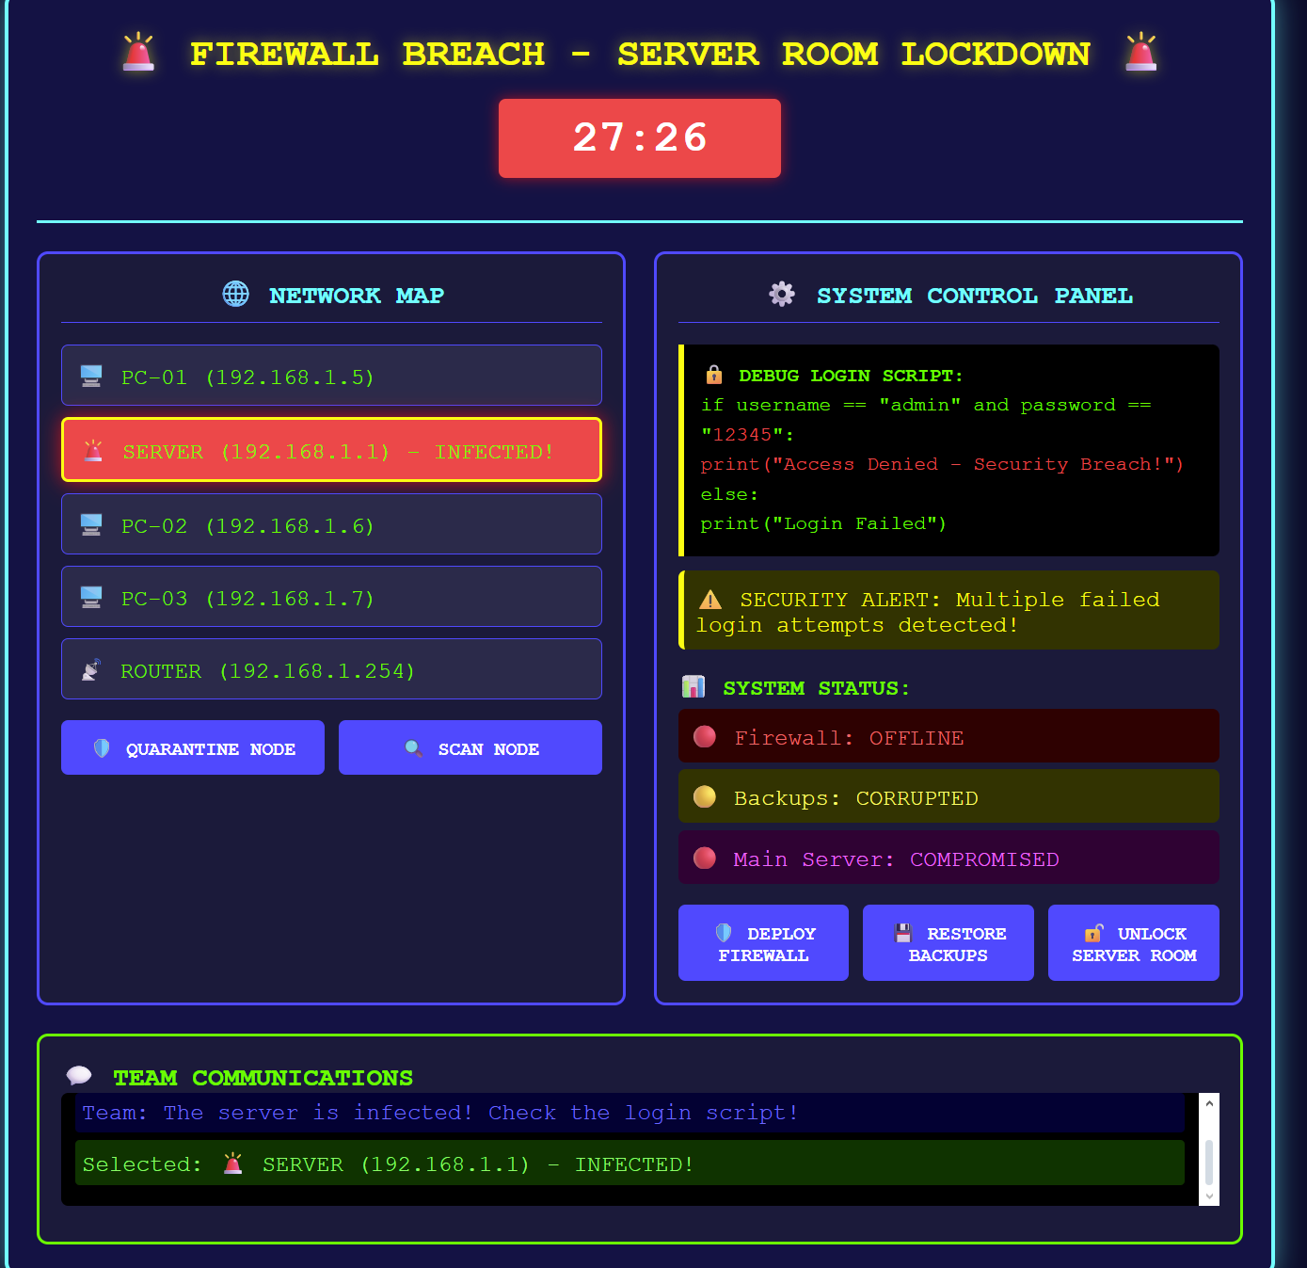
Technical Requirements
- Network: LAN connectivity for 4 players
- Visual: Clear distinction between role-specific interfaces
- Audio: Tense background music with security alert sounds
- Data: Shared game state with role-specific information filtering

Educational Value
Curriculum Alignment
- Computer Science: Networking, cybersecurity, programming basics
- Mathematics: Logical reasoning, pattern recognition, problem-solving
- Collaborative Skills: Communication, teamwork, role specialization
Learning Outcomes
- Understand basic network infrastructure
- Recognize common cyber threats
- Develop debugging and problem-solving skills
- Practice clear technical communication
- Experience coordinated team-based problem solving

Key Features & Innovation
Unique Selling Points
"It makes different IT concepts into an exciting race against time where every team member's contribution is important to success."
Innovation Highlights
- Role Specialization: Each player has unique tools and responsibilities
- Authentic IT Workflow: Mirrors real-world cyber incident response
- Progressive Difficulty: Puzzles scale from basic to advanced concepts
- Instant Feedback: Real-time consequences for actions and decisions

Comparable Games & Positioning
Similar Titles
- Keep Talking and Nobody Explodes (communication-focused puzzle solving)
- We Were Here (asymmetric information sharing)
- Hacknet (cyber security theme and interface)
Differentiation
- Specifically designed for GCSE educational requirements
- Four distinct specialized roles (vs. general collaboration)
- Curriculum-aligned IT and cybersecurity content
- Classroom-friendly time limit and complexity

Implementation Roadmap
Development Phases
- Core Framework: Basic networking and role interfaces
- Puzzle Design: Create interconnected challenge scenarios
- Educational Integration: Align with curriculum standards
- Testing & Refinement: Classroom pilot and feedback integration
Success Metrics
- Student engagement and comprehension improvement
- Teacher feedback on educational value
- Technical reliability in classroom environments
- Scalability for different skill levels

